## *Experiment No: 07*

## *Experiment Name:*

## Round Robin Scheduling Algorithm.

## *Objective:*

## In this lab we will learn about the Round Robin Scheduling Algorithm and its application.

***Round Robin Scheduling Algorithm:***

A round robin is an arrangement of choosing all elements in a group equally in some rational order, usually from the top to the bottom of a list and then starting again at the top of the list and so on. A simple way to think of round robin is that it is about "taking turns." Used as an adjective, round robin becomes "round-robin."

***Algorithm:***

1. The queue structure in ready queue is of First In First Out (FIFO) type.

2. A fixed time is allotted to every process that arrives in the queue. This fixed time is known as time slice or time quantum.

3. The first process that arrives is selected and sent to the processor for execution. If it is not able to complete its execution within the time quantum provided, then an interrupt is generated using an automated timer.

4. The process is then stopped and is sent back at the end of the queue. However, the state is saved and context is thereby stored in memory. This helps the process to resume from the point where it was interrupted.

5. The scheduler selects another process from the ready queue and dispatches it to the processor for its execution. It is executed until the time Quantum does not exceed.

6. The same steps are repeated until all the process are finished.

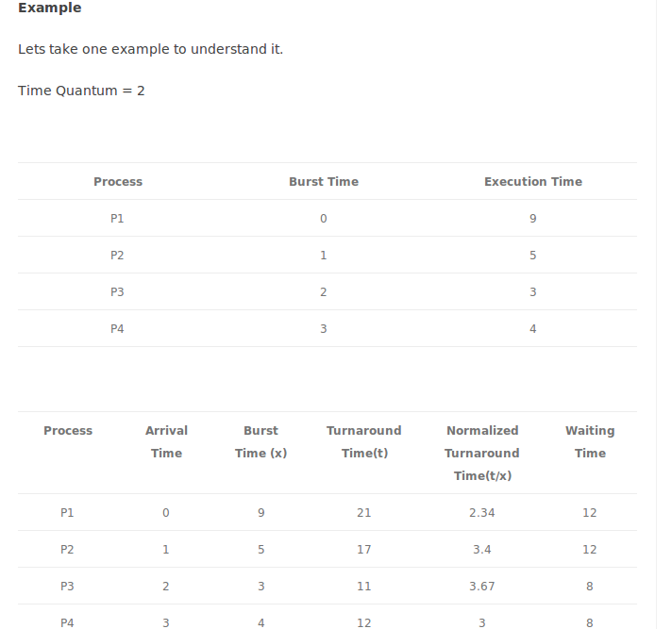

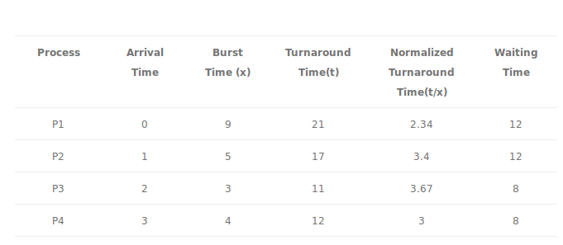

Average Turnaround Time = 15.25

Average Normalized Turnaround Time = 3.10

Average Waiting Time = 10

***Pseudo Code:***

#include<stdio.h>

int main()

{

int count,j,n,time,remain,flag=0,time_quantum;

int wait_time=0,turnaround_time=0,at[10],bt[10],rt[10];

printf("Enter Total Process:\t ");

scanf("%d",&n);

remain=n;

for(count=0; count<n; count++)

{

printf("Enter Arrival Time and Burst Time for Process Process Number %d :",count+1);

scanf("%d",&at[count]);

scanf("%d",&bt[count]);

rt[count]=bt[count];

}

printf("Enter Time Quantum:\t");

scanf("%d",&time_quantum);

printf("\n\nProcess\t|Turnaround Time|Waiting Time\n\n");

for(time=0,count=0; remain!=0;)

{

if(rt[count]<=time_quantum && rt[count]>0)

{

time+=rt[count];

rt[count]=0;

flag=1;

}

else if(rt[count]>0)

{

rt[count]-=time_quantum;

time+=time_quantum;

}

if(rt[count]==0 && flag==1)

{

remain--;

printf("P[%d]\t|\t%d\t|\t%d\n",count+1,time-at[count],time-at[count]-bt[count]);

wait_time+=time-at[count]-bt[count];

turnaround_time+=time-at[count];

flag=0;

}

if(count==n-1)

count=0;

else if(at[count+1]<=time)

count++;

else

count=0;

}

printf("\nAverage Waiting Time= %f\n",wait_time*1.0/n);

printf("Avg Turnaround Time = %f",turnaround_time*1.0/n);

return 0;

}

***Output:***

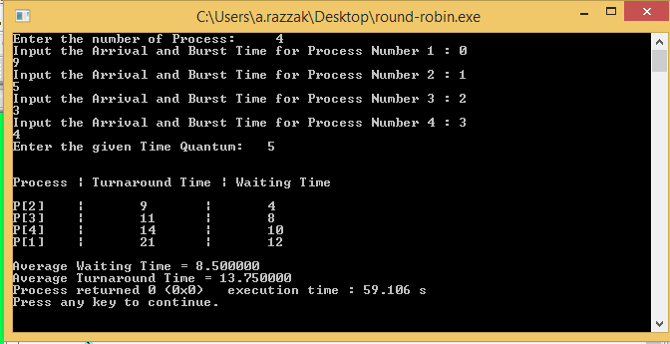

***Discussion:***

The Round Robin algorithm is simple and the overhead in decision making is very low. It is the best scheduling algorithm for achieving better and evenly distributed response time. And finally we finish our lab task without facing any kind of problem as we got the direct help of out respected course teacher.